MAGGIE’S GALLIVANT CTR
May 18th and 19th, 2007
25 miles through the scenic Cross Florida Greenway
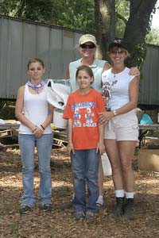
Photos Courtesy of Brandy Johnson Photography

Grand Champion – Cindi Moore on Nave Grand Reserve – Rose Miller on Remin Aja Ali

LW –
1st Deborah Walker on Cobra 2nd LuAnn Wilson on Myakka 3rd Lucille Hood on Sol Angelia 4th Ann Lane on HF Isis
5th Elaine Lemieux on Hersey
6th Maria Florkiewiez on Majeco.

Junior Grand – Cassandra Roberts on AV Temptress Junior Reserve – Monique Rawson on Ima Charmer 1st Marissa Pool on NVF BlackJack
2nd J Jenner* on JS Sedona Sun 3rd Kalee Hoffman on Whiska 4th S Lesperance* on Adida
MW

1st Carla Burton on Cracker 2nd Dwana May on Zoomie 3rd S Stamos* on Little O Jet, 4th Dottie Gould on Varykino
5th Susan Banden on Staccnamet
6th D Buick* on Found One Elegant Boy.

HW-
1st Cheryl Van Deusen on Precious Beaunita 2nd Doug Shearer on Desert Beylic
3rd Bany Cranmer on GA Expression 4th C McConnell* on Bay Brulee
5th Maris Ramsay on SA Cea Mistral 6th Laurie Allard on Shackster Beau.

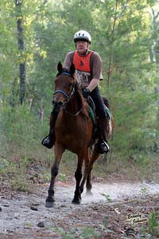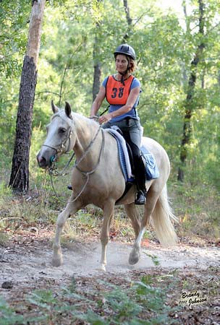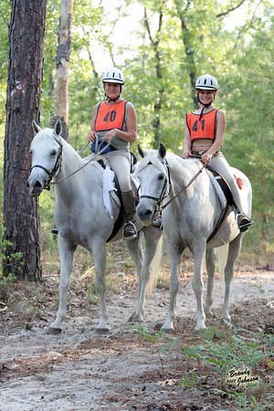

Best Rookie Horse - Mahogany Jack (TGood) Best Rookie Rider – J Jenner*
Sportsmanship – Lucille Hood
Best Horse & Rider Combo – Laurie Allard on Shackster Beau Best Horse & Rider Junior Combo – J Jenner* on JS Sedona Sun
Best Arab – Flutie (J Sparks*)
Best Half Arab- Matilda Masterpiece (Alexandra Kroh) Best Appaloosa – Nave (Cindi Moore)
Best Other Registered – Whiska (Kalee Hoffman)

Ride Completions (all the above to include): Vicky Thompson on Gizmo, Julia Shewchuck on Dusty Deller, A Mettling* on Pusher Bossamor, John Shaw on Locomotion Lassie, Donna Normand on Vom Marqee, Yvette Vinton on Faras Fali, J Sparks* on Flutie, Ruth Ann McMahon on Copper, Jodie Moore on Amazing Tribute

Volunteers-Paul Moore, Jean Shaw, Pat Thomas, Travis Egyed, Sandra Foti, Carolyn Maillard, Greg Banden, Carol Thompson, Sue Harter, Nora Mask, Sarah Daniels, Savannah Bagwell, Flisha Fitzpatrick, Maggie Gerrits, Michelle McClain, Norma Caron, Jackie Baker, Michelle and Chris Roberts, Pam Pease, Adrian and Shelley Scott-Jones, Chuck Miller Eric Bobst, Dorothy Bobst, and Brandi Bobst

